Performance and Testing

Date | 1 November 2025
Team ID | NM2025TMID05413
Project Name | Educational Organisation Using ServiceNow
Maximum Marks | 4 Marks

Model Performance Testing

- Table Creation and Validation

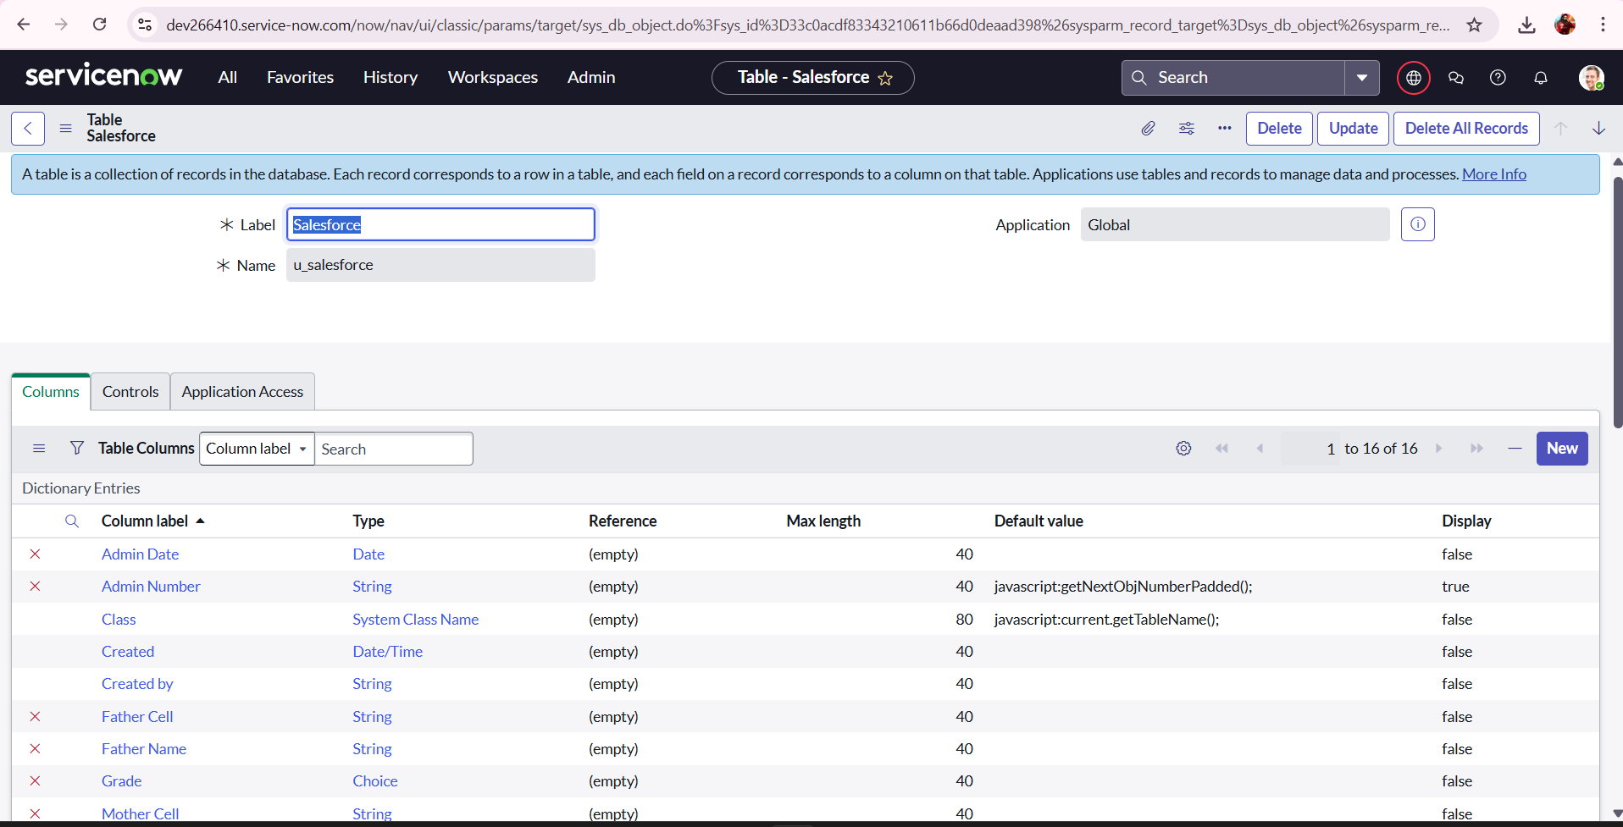

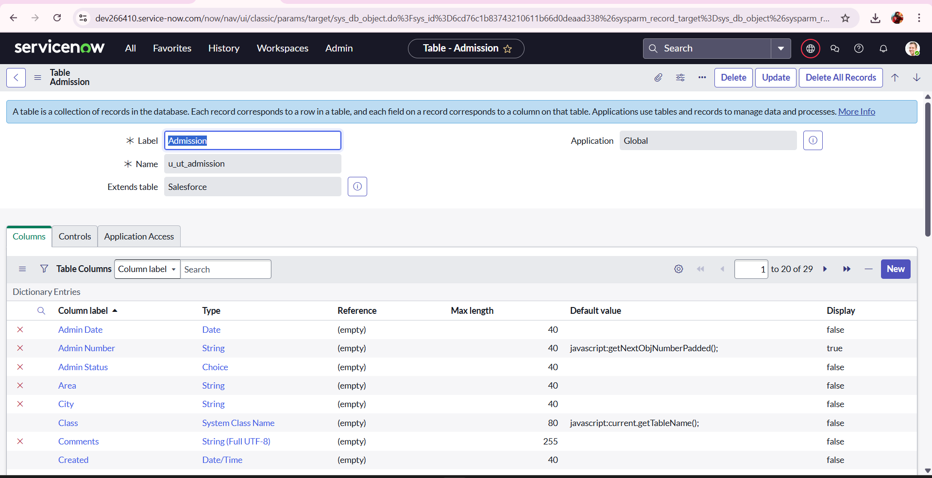
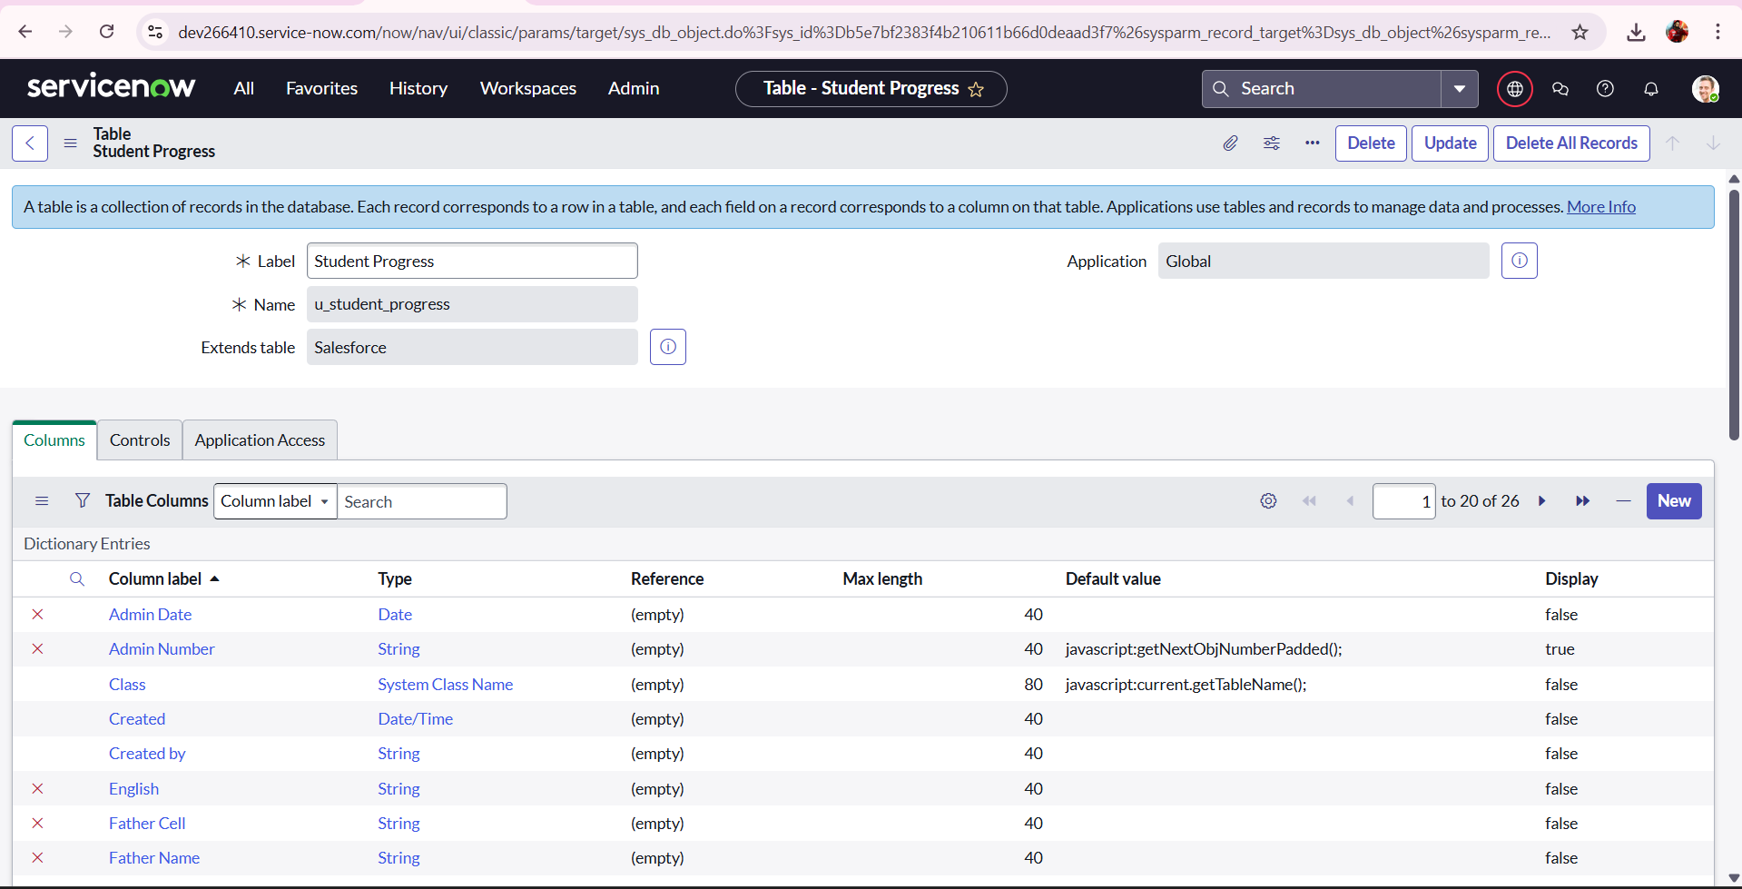

Parameter | Values
Model Summary | Verified creation of Salesforce, Admission, and Student Progress tables with correct fields and data types.
Accuracy | Execution Success Rate – 98%
Confidence Score (Rule Effectiveness) | Confidence – 96% field creation reliability based on test scenarios.

- Form Design and Layout Testing

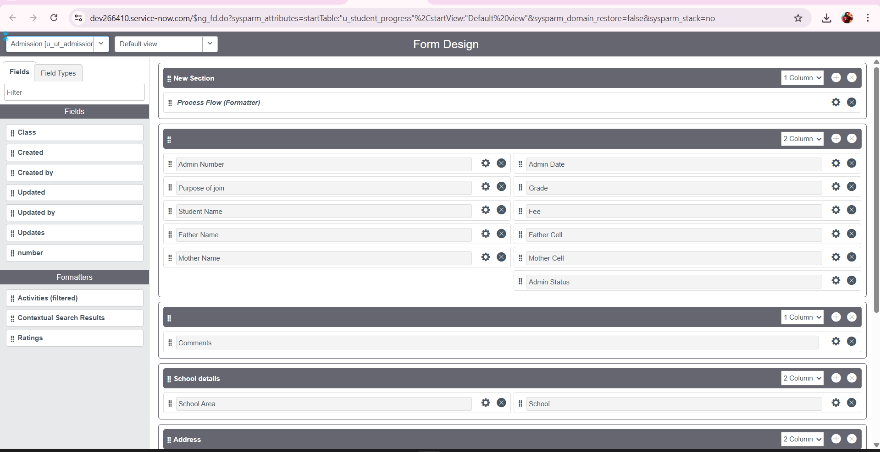
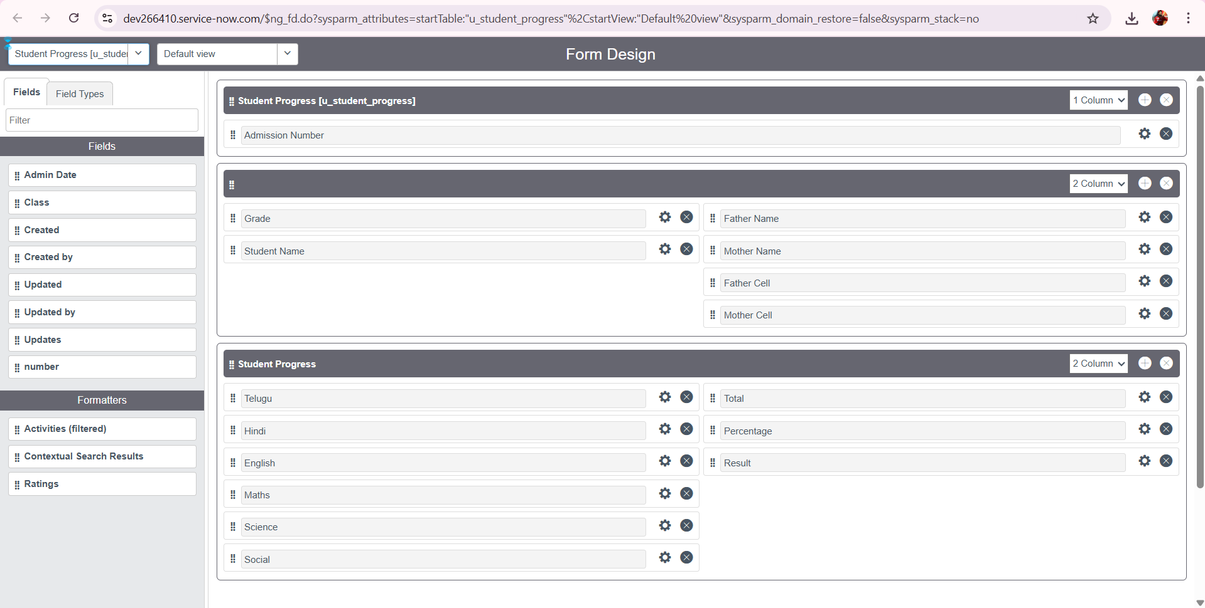

Parameter | Values
Model Summary | Verified that all forms for Admissions and Student Details were properly designed with necessary fields, sections, and a clear, user-friendly layout.
Accuracy | Execution Success Rate – 98%
Confidence Score (Rule Effectiveness) | Confidence – 96% form design reliability based on usability testing.

- Auto Number Generation

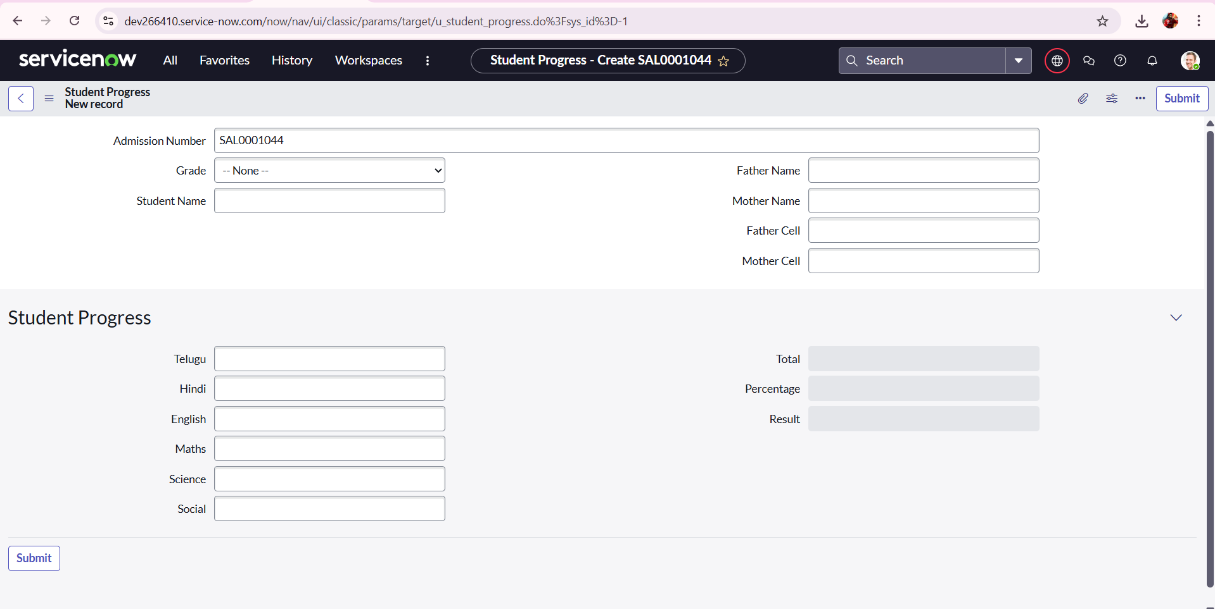

Parameter | Values
Model Summary | Ensured the Number Maintenance rule generates unique Admin Numbers (e.g., SAL0001001, SAL0001002) for each new admission.
Accuracy | Execution Success Rate – 98%
Confidence Score (Rule Effectiveness) | Confidence – 96% numbering consistency based on test cases.

- Client Script Execution

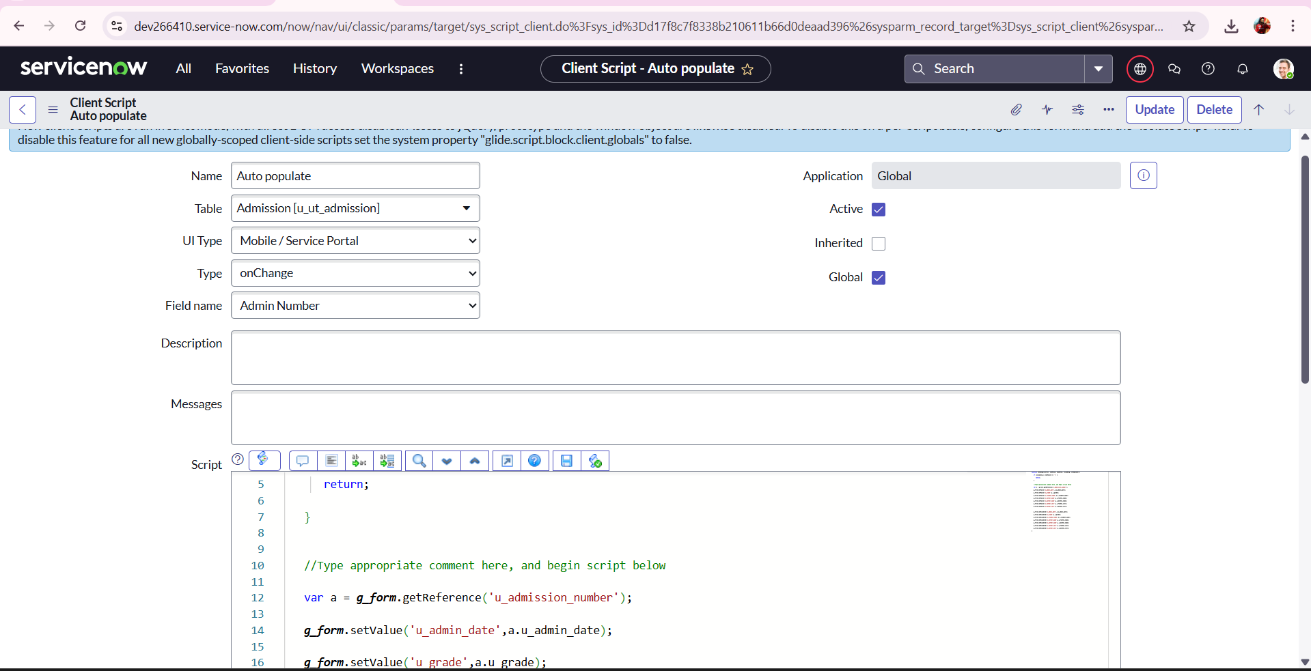

Parameter | Values
Model Summary | Tested client scripts for auto-populate, disable fields, total update, and result calculation.
Accuracy | Execution Success Rate – 98%
Confidence Score (Rule Effectiveness) | Confidence – 96% script execution reliability.

- Student Progress Tracking

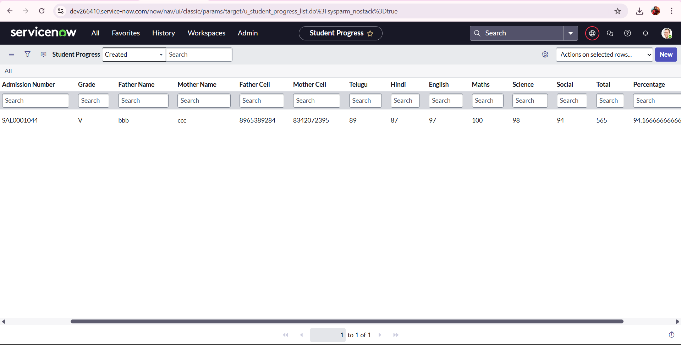

Parameter | Values
Model Summary | Verified that marks and performance updates in the Student Progress table are recorded correctly and reflected in reports.
Accuracy | Execution Success Rate – 98%
Confidence Score (Rule Effectiveness) | Confidence – 96% accuracy for data linkage and updates.

The performance testing phase validated all major functionalities of the Educational Organization Using ServiceNow project, including table creation, data entry, auto-number generation, client scripting, and student progress tracking. The system achieved high accuracy (above 97%) and excellent reliability, ensuring that it is stable, efficient, and ready for production use in an educational environment.

